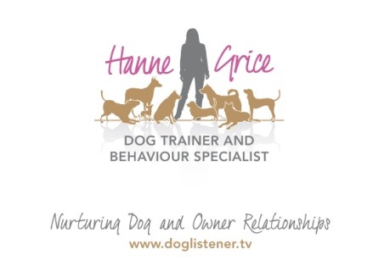
FOR IMMEDIATE RELEASE

Keeping Fido fit

‘Canine Posture, Movement & Back Pain’ workshop coming to Tring
on 18th October ‘15
Dogs, like us, can suffer from back, neck and muscle pain. After all, dogs stand on their toes with their ankles bent and knees forward all day – that’s a lot of weight and stress on Fido’s muscles and joints.
That is why Hanne Grice, a dog trainer and behaviour specialist, is hosting a special workshop presented by McTimoney practitioner Lucy Bounden. This interactive event ‘Canine Posture, Movement & Back Pain’ will give dog owners insight into dogs’ posture, movement and anatomy. Using video technology, delegates will be introduced to the world of biomechanics – where they can observe their own dogs’ movement and watch, in real-time, video relay indicating areas on their dog’s anatomy that may need further investigation.
Lucy says: “Owners may not be aware of a minor back issue or weakness in their dog and as a consequence, the problem may build up over time becoming a bigger issue. This workshop will help owners identify the early warning signs - and when to seek expert advice. In essence, prevention is better than cure.”

The workshop is part of an on-going series of events hosted by Hanne Grice and her team aimed at promoting responsible dog ownership. Hanne said: “With dog sports such as agility, fly ball and canicross becoming ever more popular, it made sense to create an event that helps people learn about their pet’s physiology and how to spot discomfort. That’s because pain can also have an impact on a dog’s psychological health which, if left untreated, may lead to permanent neurological damage.”

That is why this workshop will also highlight the measures that owners can put in place to help keep their dog’s back and muscles strong, fit and healthy.
The workshop will be held on Sunday 18th October at the Nora Grace Hall in Tring.
For further information visit: www.doglistener.tv/events or call Hanne Grice on 01442 768894.

-Ends-

Hanne Grice and Lucy Bounden are available for interviews on request.

NOTES TO EDITORS
- Canine Posture, Movement & Back Pain with Lucy Bounden MSc, will be held on Sunday 18th October ’15 at the Nora Grace Hall, Faversham Close, Tring, Hertfordshire HP23 4DR from 10am to 2pm.
- Tickets are priced at £25 for owners wishing to bring their dog along (limited to 6 places on a first-come-first-served basis) and spectator places are priced at £20. Tickets are available for purchase from Hanne Grice (t) 01442 768894 / 07976 743031 or online at www.doglistener.tv/events For further information, email Hanne at hanne@doglistener.tv
- Lucy Bounden qualified as an Animal McTimoney therapist from the McTimoney College of Chiropractics in 2012 with an MSc in Animal Manipulation. She holds a BSc (Hons) in Equine Sports Science from the University of the West of England and is a member of the Animal McTimoney Association (MAA). Lucy is based on the borders of Buckinghamshire and Oxfordshire and is the proprietor of Animal Spine, an animal health practice specialising in McTimoney therapy.
- Hanne Grice is the owner of Walk the Dog™ a multi award winning pet behaviour & pet care company based in Tring, Hertfordshire that offers a range of services from canine behavioural advice, 1-1 training and Puppy & Dog School. Hanne Grice is also the author of the book "Playing with Your Dog" and writes for a number of online publications. Visit www.doglistener.tv

