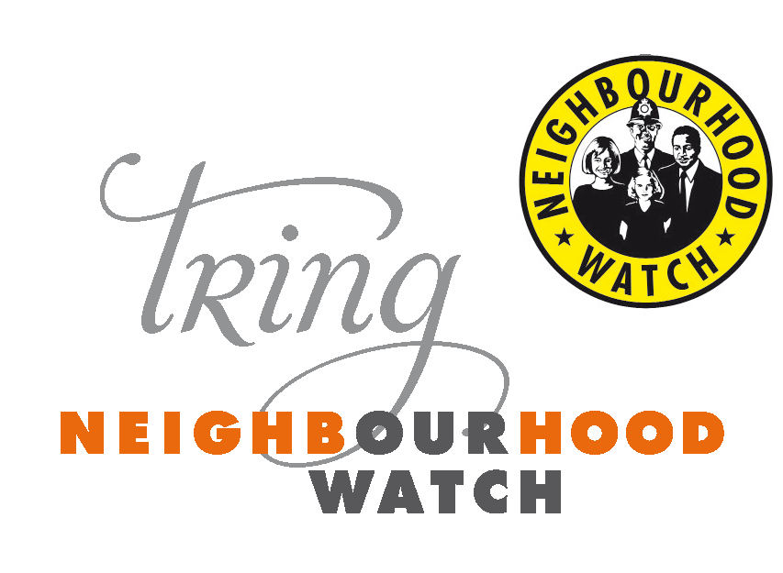
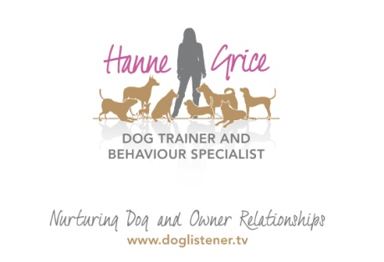

12th December 2014
The long-arm of the ‘paw’

What Every Dog Owner Needs to Know: UK’s leading dog law expert is coming to town
This week the PDSA released a report indicating that 250,000 dogs are being aggressive towards people every week, with 30 per cent of pet owners having been bitten or attacked by a dog. It also said 62 per cent of pet owners have been alarmed by another dog's behaviour.
Over the last five years, the number of hospital admissions as a result of a dog bite has been steadily increasing, with an estimated 200,000 people a year said to have been bitten by dogs in England at a cost of approximately £3 million to the NHS. High profile ‘fight and bite’ cases in recent years, as well as the fatal attack on 14-year old Jade Anderson who was savaged by four dogs when visiting the home of a friend in March 2013, sparked a review and change in UK Dog Law this year. Additional changes to the law came into effect in October. These changes can impact any dog owner, as the law not only applies to dogs that attack in public places, but now to those animals that attack within our homes and gardens too; and this legislation is applicable to any dog, whatever the breed.

Tring and Berkhamsted Dog watch are excited to announce a partnership with Hanne Grice, a local dog trainer and behaviour specialist, in hosting a series of dog related activities for 2015. On Sunday 8th February 2015, the first event will be a unique seminar by the UK’s leading expert in Dog Law, Trevor Cooper titled ‘Dog Law: What Every Dog Owner Needs to Know’. A solicitor from Cooper & Co, Trevor will be coming to Ashridge to dispel myths about the UK law, helping dog owners open their eyes to the current legislation and obvious loopholes it has. Neighbourhood Watch and Hertfordshire Constabulary representatives will be attending the event for anyone wishing to find out more about the dog watch scheme and/or sign up.

Hanne Grice says: “We’re delighted to be bringing this event to the Ashridge Estate – a place which is a favourite area for many dog walkers. In my line of work, I deal with a lot of aggression cases. Often in cases where a dog has bitten a human, this has occurred due to a misunderstanding between the two species, while dog-on-dog attacks can be borne out of fear, frustration, physical pain and in some rare instances – for fun because a dog may get a real ‘high’ from a fight so it goes out looking for trouble. Sometimes, clients may find themselves on the wrong side of the law, so knowing your rights and where you stand whether you or your dog is a victim of a dog attack, or your pet has caused the incident is vital. Putting it simply, knowing the law of the land is something every good dog owner should know.”

The event will be held at the Study Base in the Visitor’s Centre of the Ashridge Estate and is supported by the Hertfordshire Constabulary, Neighbourhood Dog Watch Scheme and the National Trust’s Ashridge Estate. For further information visit: www.doglistener.tv/events or call Hanne Grice on 01442 768894.

-Ends-

Hanne Grice and Trevor Cooper are available for interviews on request.

For more information please contact Hanne Grice 07976 743031 / 01442 768894/ hanne@doglistener.tv
- The Dog Law seminar – ‘What Every Dog Owner Needs to Know’ will be held on Sunday 8th February ’15 at the Study Base, Visitor’s Centre, The National Trust Ashridge Estate, Ringshall, Hertfordshire HP23 1LX from 11am to 2pm.
- Tickets are priced at £20 and are available for purchase from Hanne Grice at Walk the Dog (t) 01442 768894 / 07976 743031 or online at www.doglistener.tv/events
- This seminar counts towards the Dog Law Module of the UK Kennel Club Accreditation Scheme for Dog Trainers and Behaviourists.
- Trevor Cooper is regarded as a leading Solicitor in England and Wales specialising in the law on dogs. Trevor started his career in local government and has acted for both the prosecution and the defence. He currently splits his time between acting as the Doglaw specialist for the Dogs Trust in London and continues to act in dog cases in both criminal and civil matters throughout England and Wales.
- Hanne Grice is the owner of Walk the Dog™ an award winning pet behaviour & pet care company in Tring, Hertfordshire that offers a range of services from canine behavioural advice and training to small animal feeds. Visit www.doglistener.tv
- Hanne Grice is the author of the book "Playing with Your Dog" available from Walk the Dog™ plus Tesco, Waterstones, WHSmith's, Borders, Amazon online.
- Emma Cowell is the Deputy Chair and Secretary of the Tring Neighbourhood Watch. For more information about Dog Watch contact Emma on 07976 700861 / tringnhw@yahoo.co.uk

