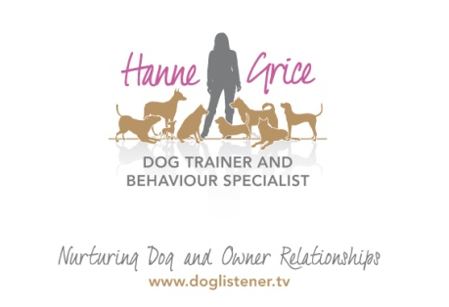
FOR IMMEDIATE RELEASE

Pilates for Dogs

‘An Introduction to Canine Exercise’ workshop coming to Tring – 18th July ‘15
Our four-legged friends stand on their toes, ankles in the air with their knees forward. Imagine doing that all day and you will have a better idea of the weight and stress Fido puts on his muscles and joints. It takes lots of energy, strength, and flexibility to chase squirrels, scratch behind ears, wrestle with playmates or leap for toys. And, if you have a dog involved in sports and activities - whether that is agility, fly ball, showing or he is simply your running partner, then knowing how to maintain your pet’s health and wellbeing is vital.
That is why Hanne Grice, a local dog trainer and behaviour specialist, is hosting a unique workshop presented by UK Husky Racing Champion, Emma Cowell. This hands-on workshop ‘An Introduction to Canine Exercise’ will present the basic physical, mental and emotional principles needed to help keep your dog fit. The workshop will include exercises that you can incorporate into daily life (whatever the age of your dog) and will develop a strong core stability and balance, factors that are so important for correct movement.
Emma Cowell says: “This is an excellent opportunity for pet owners to learn how to assess their dog’s fitness and behaviour levels, consider the climate and terrain they are exercising in and on, as well as the dog’s hydration levels, nutrition, plus a whole lot more. Basically, think of this as Pilates for dogs!”
Hanne Grice says: “With cani-cross clubs (running with your dog) and bike joring (cycling with your dog) becoming ever more popular in the Dacorum area, it made sense to create a fun and informative workshop that not only benefits a dog’s emotional and physical health but also builds a better bond between dog and owner.”
The workshop will be held on Saturday 18th July at the Nora Grace Hall in Tring.
For further information visit: www.doglistener.tv/events or call Hanne Grice on 01442 768894.

-Ends-

Hanne Grice and Emma Cowell are available for interviews on request.

- An Introduction to Canine Exercise will be held on Saturday 18th July ’15 at the Nora Grace Hall, Faversham Close, Tring, Hertfordshire HP23 4DR from 9am to 12pm.
- Tickets are priced at £25 for owners wishing to bring their dog along (limited to 6 places on a first-come-first-served basis) and spectator places are priced at £20. Tickets are available for purchase from Hanne Grice courtesy of Walk the Dog (t) 01442 768894 / 07976 743031 or online at www.doglistener.tv/events For further information, email Hanne at hanne@doglistener.tv
- Emma Cowell is an accomplished husky racer. She has held various UK titles over the last ten years. This includes the UK’s first Championship team to complete the world’s Northern most sled dog race in Arctic Norway in 2013, (known as the ‘Finnmarkslopet’) which is over 500km. Emma is currently combining her passion for sled dogs through an awarded scholarship to research human-animal bonding. This takes her back and forth to Arctic Norway, where she has been conducting talks and workshops on Canine Exercise to pet owners, hunting clubs and the mushing community.
- Hanne Grice is the owner of Walk the Dog™ a multi award winning pet behaviour & pet care company in Tring, Hertfordshire that offers a range of services from canine behavioural advice and training to small animal feeds. Visit www.doglistener.tv
- Hanne Grice is the author of the book "Playing with Your Dog" available from Walk the Dog™ plus Tesco, Waterstones, WHSmith's, Borders, Amazon online.

