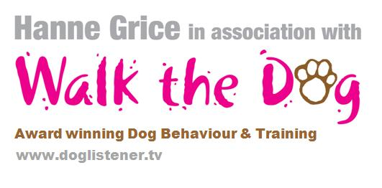
30th September 2014

Now we can find out what our pet really thinks of us

UK's leading Animal Communicator & Pet Psychic is coming to Tring

With the school half term just around the corner, most of us will be spending more time at home with the family and there may be more people around than usual, this could lead to confusion for the family pet. Some dogs react differently to changes in the daily routine which can lead to misunderstanding and may even affect their behaviour.

Hanne Grice is a dog trainer and runs an award winning pet behavioural company. She holds specific workshops on dog behaviour to help owners understand their dogs better and generally help the four legged friends in our lives deal with any demands or changes to the usual routine.

Our pets communicate all the time through a combination of visual, verbal and olfactory cues and signals; however these can often be misinterpreted by owners. So, wouldn’t it be simpler if we could just talk to our pet and get an answer back? Well, now that might be a possibility!

Hanne is hosting a very different type of workshop from her usual, joining forces with the UK’s leading Animal Communicator and Pet Psychic Michelle Childerley. Michelle has worked with a wide range of species across the globe, assisting wildlife and safari parks to horse racing trainers and beyond. Michelle’s abilities have been studied by scholars at the University of Cambridge and she is a regular on BBC One, Sky1 and recently completed filming a series with Freemantle Media.

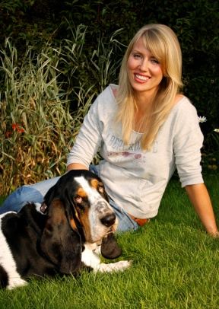
Hanne says: “While most owners will recognise when their pet is fearful or happy, the language of dog can be subtle ranging from a glance, tensing of muscles or a slight shift in the dog’s posture to something more obvious, such as a play bow or a loud bark. And, it can be complex; a given gesture may have multiple distinct meanings depending on the situation and the accompanying behaviours. So, Michelle’s work brings a completely new dimension in understanding how our pets may think and feel. I believe it’s important to be open-minded whatever the species we’re working with, and that’s why I’ve invited Michelle to come and share her knowledge.”

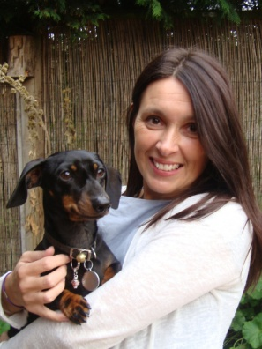
The Level 1 workshop will explore what Animal Communication is all about – teaching students how to receive information from animals, as well as provide exercises on how to develop telepathic ability and practice communicating distantly with an animal using a photo, plus much more.

Michelle says: “My workshops are open to anyone who wants to gain an insight, improve understanding and enhance their skills of Animal Communication. I’m really excited to be coming to Tring as I know the local area is packed with animal lovers. So, I’m hoping to get to meet lots of owners who are interested in connecting further with their pets.”

-Ends-

Hanne Grice and Michelle Childerley are available for interviews on request.

For more information please contact Hanne Grice 07976 743031 / 01442 768894/ hanne@doglistener.tv

- The Animal Communication Level 1 workshop will be held at The Memorial Hall (formerly known as the Red Cross Hall) Faversham Close, Tring, Hertfordshire HP23 5BA on Sunday 23rd November ‘14 from 10.30am to 4.30pm.
- Tickets are priced at £40 and available for purchase from Hanne Grice at Walk the Dog (t) 01442 768894 / 07976 743031 or online at www.doglistener.tv
- The workshop will cover;
  - What is Animal Communication?
  - Looking at how you will receive information from animals
  - Exercises on how to develop telepathic ability
  - Exploring the right brain hemisphere to receive intuitive thoughts
  - Send and receive information telepathically
  - Practice communicating distantly with an animal using a photo
  - Communicating with animals in spirit
- There are 5 CPD available for this course.
- Michelle Childerley is an animal communicator and pet psychic. A regular face on television, Michelle is the author of the book “A Meeting of Minds”.
- Hanne Grice is the owner of Walk the Dog™ an award winning pet behaviour & pet care company in Tring, Hertfordshire that offers a range of services from canine behavioural advice and training to small animal feeds. Visit www.doglistener.tv
- Hanne Grice is the author of the book "Playing with Your Dog" available from Walk the Dog™ plus Tesco, Waterstones, WHSmith's, Borders, Amazon online.
- Walk the Dog™ - winners of the Special Merit Award 2007, 2008, 2009 from NARP and the Dacorum Business Award 'Most Promising Business' 2009.

