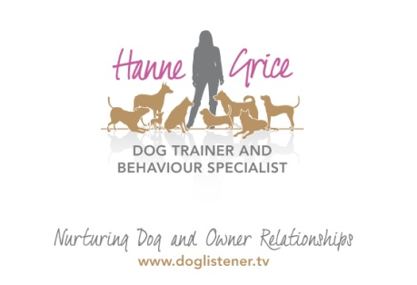
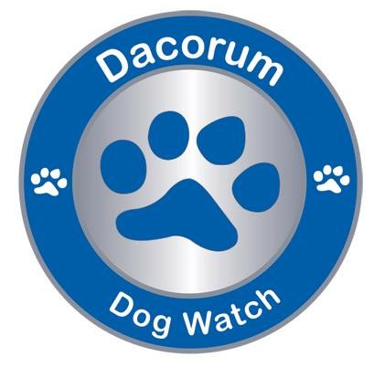

20th June 2016

Dogs that Bite & Fight

Bestselling author and behaviourist David Ryan to share advice on tackling dog aggression
According to the latest PDSA Animal Wellbeing (PAW) Report, nearly 250,000 dogs act aggressively towards people each week and over 600,000* dogs are showing aggression towards other pets. Official statistics published last year showed that hospital admissions for injuries caused by dogs had risen by 76% in England in a decade.
Only last month a Staffordshire bull terrier attacked more than a dozen children at a park in Northumberland, a 45 year man was killed by a dog in Cumbria and, closer to home, Kyle David, a 10 year old boy, was set upon by an Akita while out walking in St Albans. Breed type and a lack of responsible ownership is often put at blame, but what about those owners who are responsible yet live with dog reactivity day to day and don’t know how to stop it? David Ryan, a certified clinical canine behaviourist, will be sharing insights about dog on dog aggression and dog to human aggression at his forthcoming seminar in Tring entitled ‘Dogs that Bite & Fight’.
David says:”The problem of dogs biting people and fighting other dogs is getting worse. Every year the NHS dog bite figures increase, court cases for dangerous dogs are at an all-time high, the government is still failing to tackle the issue of “status dogs”, postal and other delivery workers and assistance dog users are demanding protection. Behaviourists’ like me have case-loads full of biters and fighters. No sensible person wants their dog to bite them, anybody else or to fight with other dogs.”
David is joining forces with local dog trainer Hanne Grice, to present a one day seminar all about dog aggression. Hanne says: “This event will provide a complete understanding of why pet dogs become biters and fighters, how to prevent it and how to change the behaviour. The day is aimed at pet owners and professionals living or working with dogs that are reactive in various situations, whether that’s out on a walk or in the home. This event includes practical training methods that owners can use with their own animals.”
This one day seminar is being supported by Tring and Berkhamsted Dog Watch, as part of a number of events in conjunction with Hanne Grice that promotes responsible dog ownership in the local community. Dog Watch is part of Dacorum Neighbourhood Watch and invites dog owners to be the eyes and ears of their community when out walking their dogs, reporting suspicious activity to the authorities
The event will be held at the Nora Grace Hall in Tring on Saturday 16th July 2016. For further information visit: www.doglistener.tv/events or call Hanne Grice on 01442 768894.

-Ends-

Press contact:
Hanne Grice
07976 743031 / 01442 768894
hanne@doglistener.tv

NOTES TO EDITOR:
- The Dogs that Bite & Fight seminar will be held on Saturday 16th July at the Nora Grace Hall, Faversham Close, Tring, Hertfordshire HP23 BA. The event is from 10am to 4pm.
- Tickets are priced at £50 (includes lunch and refreshments) and are available for purchase from Hanne Grice Training & Behaviour (t) 01442 768894 / 07976 743031 or online at www.doglistener.tv/events
- David Ryan is regarded as one of the UK’s leading certified clinical behaviourists. He is a bestselling author, and has published a number of books on canine behaviour. David was a police dog handler and instructor for twenty-six years. He cut his teeth on dogs that bite and fight, teaching them how to moderate and direct aggression proportionately. He learned the art of conducting the aggression in a dog like a musical instrument, lifting, lowering and directing it under control and on cue. In his time David was bitten over fifty thousand times, usually on the intended padding, which started off as carpet remnants and old copies of Police Review and eventually evolved into purpose-made sleeves with integral bite-bar. David knows what both ends of the problem feel like.
- Hanne Grice is the owner of Hanne Grice Dog Training & Behaviour (formerly Walk the Dog™), an award winning pet behaviour company based in Tring, Hertfordshire. Hanne and the team offer a range of services from canine behavioural consultancy, one to one training, group classes, educational workshops and more. Visit www.doglistener.tv
- Hanne Grice is the author of the book "Playing with Your Dog" available from Amazon and other online resellers.
- For more information about Dog Watch contact Emma Cowell on 07976 700861 / tringnhw@yahoo.co.uk

* PDSA Figures calculated using estimated pet population of 8.1 million dogs in the UK, therefore calculations are as follows:
- 8,100,000 (estimated dog population) x 3/100 (3% of dogs showing aggression towards people on a weekly basis) = 243,000 dogs.
- 8,100,000 (estimated dog population) x 8/100 (8% of dogs showing aggression towards other pets on a weekly basis) = 648,000 dogs

