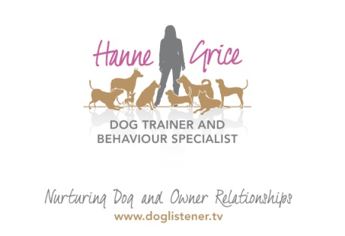
20th March 2015

Cat Chat: Learn the language of your cat

Feline behaviour workshop is coming to Tring.
It’s estimated that there are over 8 million* cats in our homes across the UK, and this figure is on the increase. In fact, cats are so popular that Berkhamsted and Tring now have their own ‘Cat Lover’s’ pages on Facebook. But how much do we really know about our four-legged friends?
As part of a special series of events aimed at pet owners and pet professionals, trainer and behaviour specialist Hanne Grice, is hosting a Cat Behaviour Workshop on Sunday 19th April in Tring. The event is presented by veterinarian Dr Anne-Marie Svendsen Aylott, Cand.Med.Vet, MRCVS.
Hanne says: “While there are various events across the region for dog owners, there’s very little out there for cat lovers. That’s why I’ve created this workshop with Anne-Marie. The event will give owners an insight into how cats communicate and the natural lifestyle of the cat, as well as looking at common behavioural problems. It’s a unique opportunity for pet owners to gain a deeper understanding of what is means when a cat exhibits certain behaviours - and how we can create a much happier kitty.”
The Cat Behaviour Workshop will be held at the Nora Grace Hall in Tring on Sunday 19th April in Tring. Tickets are £12 and attendees will have the chance to see a combination of footage and stills, as well as live cat interactions on the day.
For further information visit: www.doglistener.tv/events or call Hanne Grice on 01442 768894.

-Ends-

Hanne Grice and Dr Anne-Marie Svendsen Aylott are available for interviews on request.

For more information please contact Hanne Grice 07976 743031 / 01442 768894/ hanne@doglistener.tv
*Source: Pet Food Manufacturers’ Association http://www.pfma.org.uk/pet-population-2014/

Notes for the editor
- The Cat Behaviour Workshop will be held on Sunday 19th April ’15 at the Nora Grace Hall, Faversham Close, Tring HP23 5BA from 10.30am to 1.30pm.
- Tickets are priced at £12 and are available for purchase from Hanne Grice (t) 01442 768894 / 07976 743031 or online at www.doglistener.tv/events This workshop is aimed at cat owners and pet care professionals.
- Dr Anne-Marie Svendsen Aylott is a vet at the Wheelhouse veterinary surgery. Originally from Denmark, Anne-Marie ran her own veterinary practice for many years. After a break working extensively with cat and dog nutrition, she did a further education as a coach and master communicator, reflecting the fact that in practice she loves working as much with the clients as the patients. Anne-Marie is passionate about all things cats and has been around them since she was born. She is also a breeder of Somali’s – and delegates will have an opportunity to meet at least one of Anne-Marie’s Somalis at the workshop.
- Hanne Grice is a dog trainer and behaviour specialist. She is the owner of Walk the Dog™ an award winning pet behaviour & pet care company in Tring, Hertfordshire that offers a range of services from dog training, puppy classes to pet care. Visit www.doglistener.tv Hanne Grice is also the author of the book "Playing with Your Dog" ISBN: 978-1453529645.

