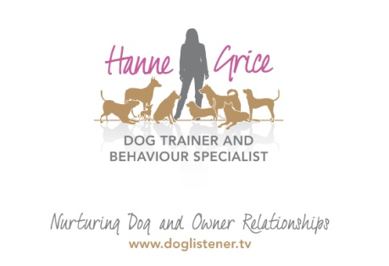
FOR IMMEDIATE RELEASE

Local dog trainer wins business award
Tails are wagging all across Dacorum this morning as the news that Hanne Grice, a local dog trainer and behaviour specialist, has collected her sixth business award at a prestigious ceremony in London.
Competing against more than 400 other nominations in the Scoot Headline Awards, Hanne and her pet behaviour business Walk the Dog™, picked up the award in the category ‘Sole Trader – Regional Winner’.
The awards which took place on Monday 20th April at the London Transport Museum in Covent Garden, recognises Britain’s most successful companies.
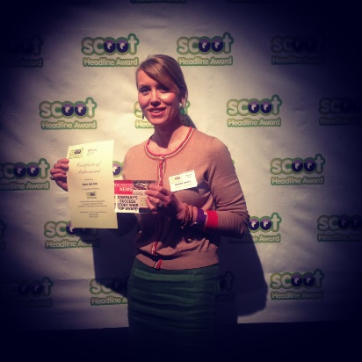
Hanne said: “As we enter our ninth year in business, we’re delighted to have won this award for our dog training & behaviour work. The team and I are passionate about giving our clients both human and furry a brilliant service, so it’s fantastic to be recognised for our efforts.”
Walk the Dog was established in 2006 and offers a range of services from Puppy & Dog School and pet care to helping owners with problem pets, as well as organising events & workshops for pet professionals.
For further information visit: www.doglistener.tv

-Ends-

Hanne Grice is available for interviews on request. For more information please contact Walk the Dog on 07976 743031 / 01442 768894/ hanne@doglistener.tv
Notes for the editor
- Hanne Grice is a dog trainer and behaviour specialist. She is the owner of Walk the Dog™ an award winning pet behaviour & pet care company in Tring, Hertfordshire that offers a range of services from dog training, behaviour modification, puppy & dog classes to pet care and events. Visit www.doglistener.tv
- Hanne Grice is the author of the book "Playing with Your Dog" ISBN: 978-1453529645.
- Hanne has won a number of awards both nationally and locally for her work and has represented female entrepreneurs presenting in front of government bodies and Ministers.
- Hanne contributes to a number of publications sharing advice on canine behaviour, animal care and management. And has given expert advice on the BBC Breakfast sofa, BBC Radio 5 Live, Talk Sport, as well as BBC Three Counties.

